Mockito
Exercise 1: Mocking and Stubbing
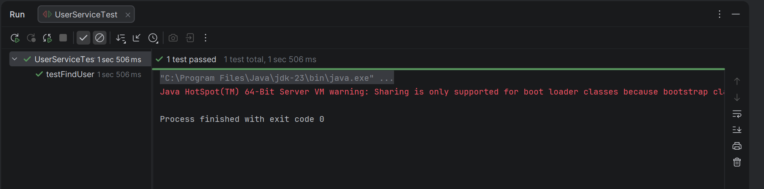

Exercise 2: Verifying Interactions
Correct Case:
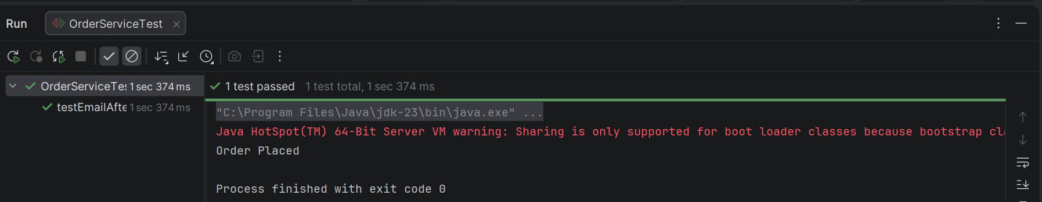
Wrong Case:
